SAP Visual Intelligence

SAP Visual Intelligence from SAP AG is a new application which provides visualizations by charts to datasets from multiple data sources. The product is a stand-alone application installed locally and can connect multiple data sources such as SAP BusinessObjects Universes, SAP HANA, Freehand SQL, which allows users to select different databases directly, install database drivers if necessary and write their own SQL SELECT Statements directly against the database and other Data Sources include MS Excel and CVS File.

SAP Visual Intelligence in its earlier version service packs initially connected to SAP HANA database system allowing users of this system to create Crisp looking Visualizations using different chart types as Displays. It also connected to Excel Files, CSV Files. As service packs got upgraded other data sources were added such as Free Hand SQL, SAP BusinesObjects Universes. With respect to delivery initially we could save the Charts created as Graphic Files and save them to Office documents, and or as attachment email files. Later ability to export the underlying dataset which is displayed on the graphs as visualization was now available to export to SAP BusinessObjects Explorer CMS to be used as a source to create an Information Space in Explorer tool which can be used to create Exploration Views and also be accessed from iPad BI Mobile Explorer Exporting document to SAP StreamWork was also added.

So in short there seems to be a sort of integration going on to communicate, transfer and share data between multiple SAP Products. Typically SAP BusinessObjects covers SAP BusinessObjects Universes and SAP BusinessObjects Explorer. Universes have been the traditional Semantic Layers for Business Objects users over the years and now this channel of source continues as parallel to other legacy SAP Systems. SAP HANA is now the de facto underlying database which will be used to run SAP BW, SAP AG's traditional Business Warehouse used for Reporting and Analysis.

So products such as SAP Visual Intelligence, SAP BusinessObjects Explorer, SAP BusinessObjects Web Intelligence, SAP BusinessObjects Analysis, SAP Crystal Reports, SAP BusinessObjects Dashboards and SAP BusinessObjects Business Intelligence Mobile Applications such as Mobile BI, Experience and Explorer for Apple's iPad all have incentives in able to use to share data sources, transfer data and share data between them.

Each of these products have specific needs and goals and purposes for users, but there is also some common ground between them, more like intersection of Venn diagrams. For now let’s look into SAP Visual Intelligence and will revisit the overlay of the different product attributes for a later discussion.

For SAP Visual Intelligence its Primary Goal is to provide the users a quick and alternate avenue to build crisp looking Charts based on Different Chart Types and saved as Visualizations (.SVID) files which can be shared as email attachments and or embedded as graphic display in documents or export data to multiple reporting and corporate servers.

When we open a .SVID file we primarily observe two main components, one is the dataset(s) and other the Visualization(s) based on the datasets. Dataset in short is the collection of data items (objects, measures, attributes, filters applied) we choose as Scope of Data for Visualization during Acquisition process. Visualization is displayed Chart or even a table based on the datasets. Each of the individual visualization can be saved as a thumbnail during development process and a set of datasets and visualizations can be contained as part of one document which is now saved under SAP Visual Intelligence Documents (Default Folder created during installation) under My Documents folder.

Our main steps during the cycle of development are - Scope and Acquire data, Prepare and Manipulate data for cleansing and custom calculations, Build Visualization and Share Visualizations.

SAP Visual Intelligence’s main product out are set of Charts and Datasets. We can export, save, share these datasets and Visualizations for business consumption and or further usage by other SAP Business Intelligence tools.

Let’s look into SAP Visual Intelligence Tool to create Visualization and in the process go over some basic steps and options for creating a quick Visualization.

First we launch our program and when SAP Visual Intelligence opens initial home screen appears as shown below.
We have a Document Browser on the left side which shows Welcome screen, All components, Documents saved as SVID Files, Datasets saved, Visualizations saved and samples.

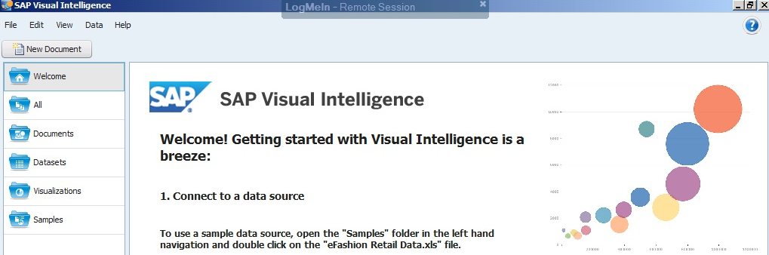

Fundamentally we have two components making up the file which contains Visualizations (Charts) based on Datasets (Data Extracted during Acquisition and saved in file). We will go over the process of creating a set of Visualizations from a data set.

First Step to create a New SAP Visual Intelligence Document – Select – New Document Button from Home Page:
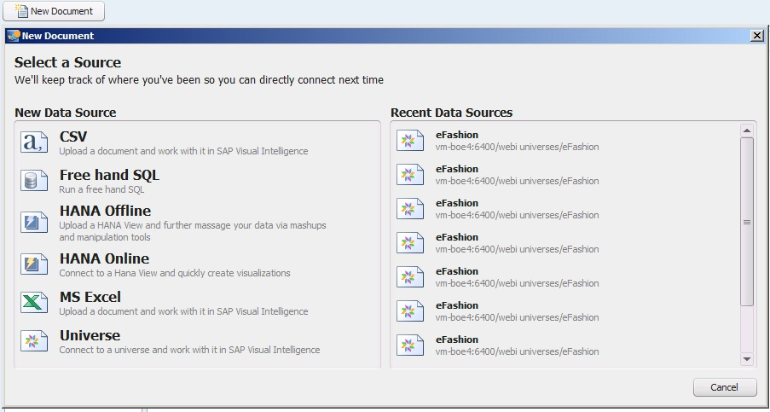

We are provided with a list of Data Sources. We can choose Ms Excel, C.S.V File, Freehand SQL, SAP HANA Cube Online and SAP HANA Cube Offline and SAP BusinessObjects Universes.

For our exercise select select eFashion Universe which is a standard universe and database which is created as part of SAP BusinessObjects Business Intelligence Enterprise installation and has objects which we can use to quickly create a sample dataset to use to create visualization.
Select eFashion Universe and provide CMS and User credentials to connect to SAP BusinessObjects Server:
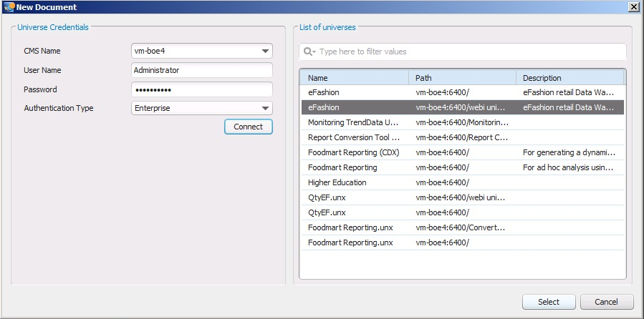

Once connected we are shown a universe tree – which basically shows list of objects and classes in the universe
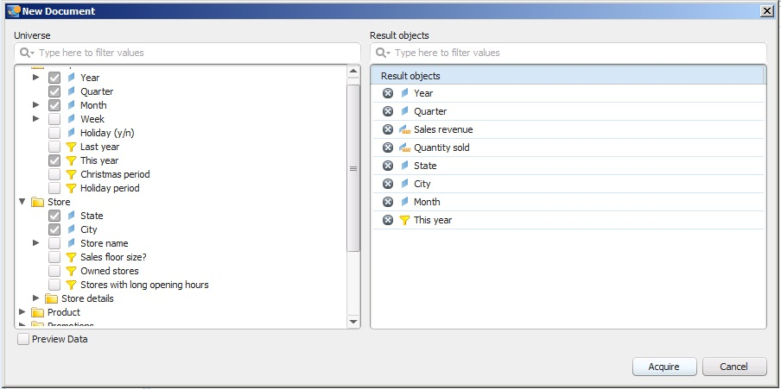

Select Dimensions, Measures, Universe Filters (if want to restrict data). This forms our query, which in this case we requested to see Quarterly Sales Revenue and Quantity Sold by State and City for the most current year in the database.

Here we can directly click – Acquire button –which will execute the query and retrieve data or we can check the Preview Data check box which will show all the columns being returned and can further filter columns which we want.
Select Preview Data Button to review the selection:

We have a Select All/None Check Box which can be used or we can select individual columns needed to Acquire
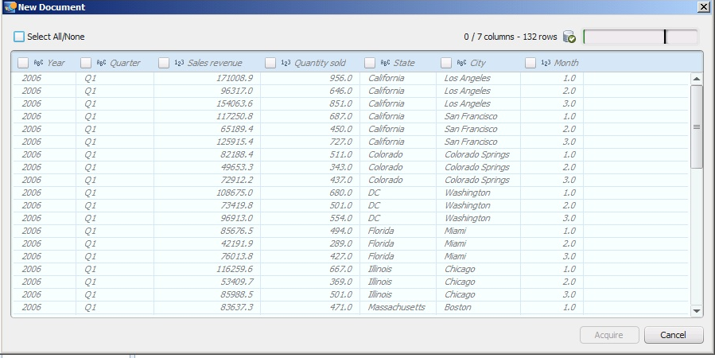
In this case we have unchecked Object Month, though we had it in our original Query. Click Acquire.
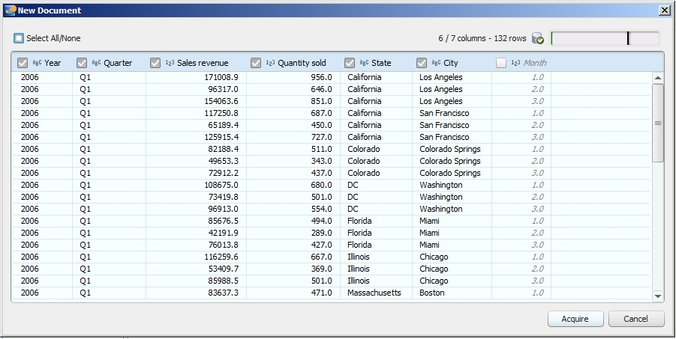

SAP Visual Intelligence Acquires data from the data source and presents it in main development panel window called Prepare Mode. There are two modes in SAP Visual Intelligence – Prepare Mode and Share Mode. Prepare Mode is where we see the list of objects acquired, manipulate the raw data if required for business needs and build and save charts from different chart families. Share Mode is a separate window showing use the list of datasets and visualizations saved in the document and provides us options to export and share.

Prepare Mode
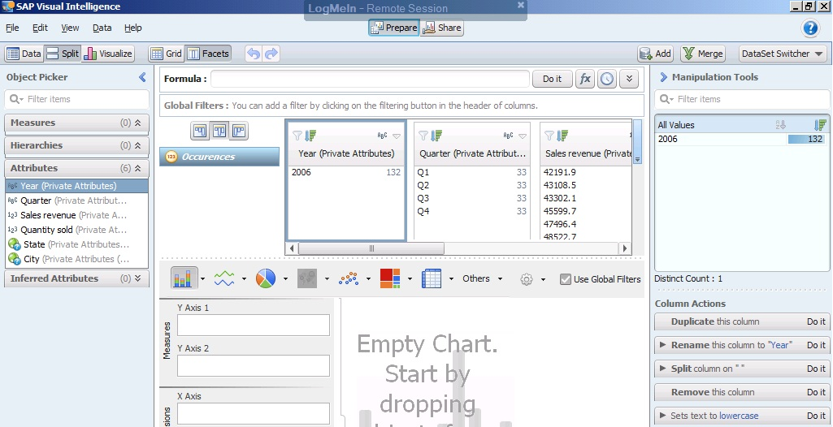
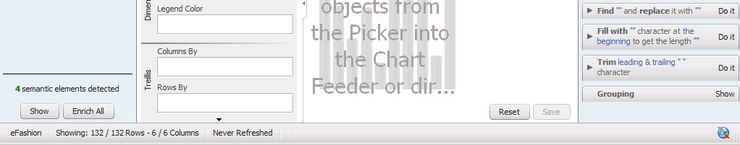

Share Mode
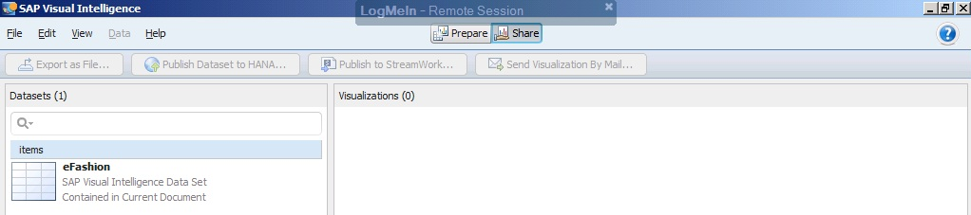

Currently we have only selected a SAP BusinessObjects Universe and ran a query and Acquired a dataset and that is the dataset – eFashion we see in the dataset list above on the left. Once we add saved visualization based on this datasets or others we should see them on the right hand side under Visualizations.

In Preview mode we observed multiple windows and buttons on top. Let’s go over the these window panes and buttons and their functionalities:
One the Top is always – Preview and Share Buttons to move from one Window to Another.

Grid – Facet – These two buttons show the dataset acquired in two modes.

The Grid shows all data acquired in rows and columns. In the simplest form is the table result of the query data returned.
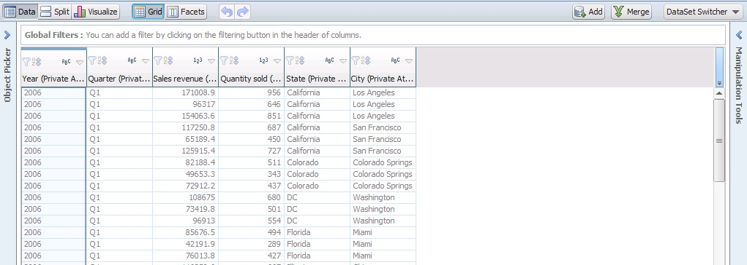
Facet shows distinct values in columns and unlike Grid don’t show repeating values. 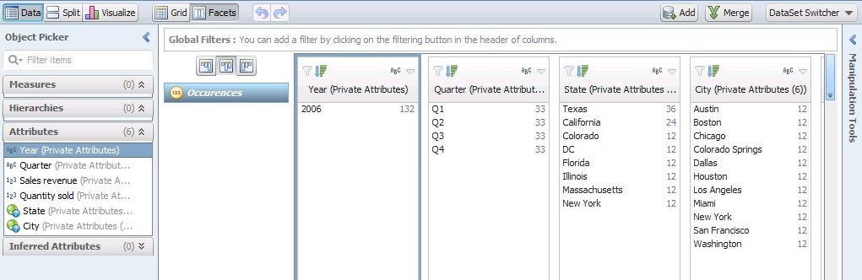
On the left hand side we observe a panel called – Object Picker Pane as shown below
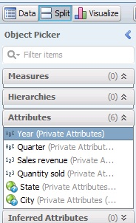
This is the Semantic Pane showing the objects into categories of Measures, Hierarchies, Attributes and Inferred Attributes. The Object Picker Pane acts as the main source to allow objects to be dragged and dropped into charts or click on contextual menu of objects and add them to new or current charts for visualization and also perform other additional functions.

Enrichments – When we acquired data SAP Visual Intelligence shows possible candidates for Measures, Hierarchies such as Time and Geography. We can choose to complete enrichment or remove recommended objects or postpone enrichments. b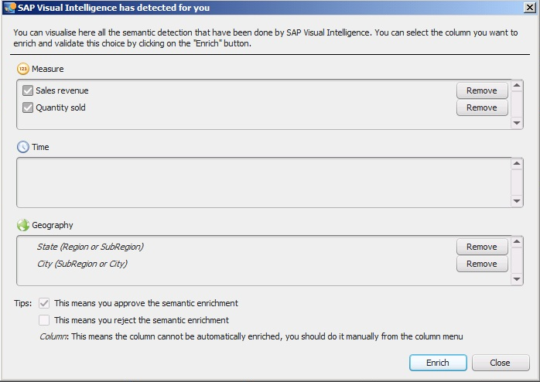
If we choose to enrich the two measure candidates then they would be applied aggregation function and will be shown as Measures once enrichment completes in Facets View.
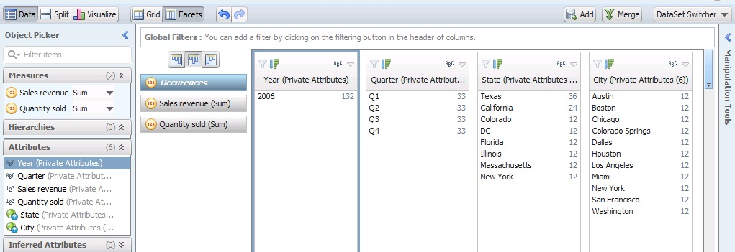
We will also look into Geographic Enrichment, which will typically allow us to create a Hierarchy based on the Geography database and dataset related data to match level of granularity for the geographical region such as Country, Region , Sub-Region, City and also we can use Latitude and Longitude data to capture the same. We will look into it in more detail later.

The Data-Split-Visualize buttons allows us to change the view of the screen. Data will only show data like what we saw for Grid-Facet. Split will show both Data and Visualize Panes. Visualize Pane is typically at the bottom of Grid-Facts Pane, but by using Visualize Pane we can fill the screen for more space during chart building or viewing. Also the Object Picker Pane on the Left Hand side and Manipulation Tools Pane on the right hand side can be collapsed to give a wide area of space for charting.

Let’s first look at creating a basic chart.
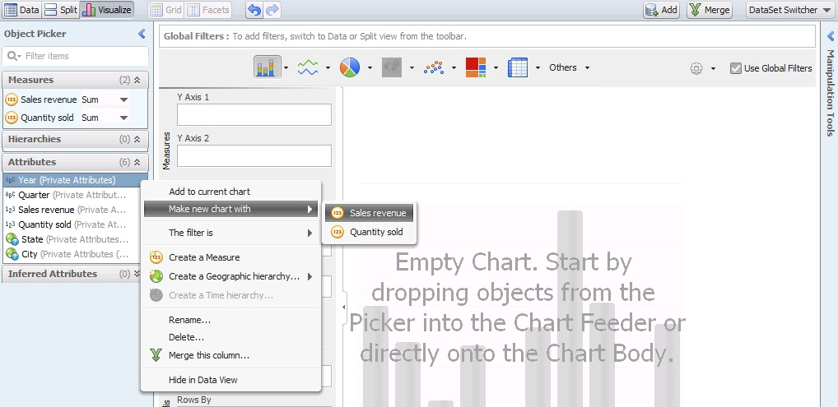
Here we are creating a new chart based on Year and Sales Revenue Measure, by selecting the Attribute and clicking the right arrow which opens its contextual menu and we chose Make new chart with Measure – Sales revenue. We can also drag and drop this object in the charting area.
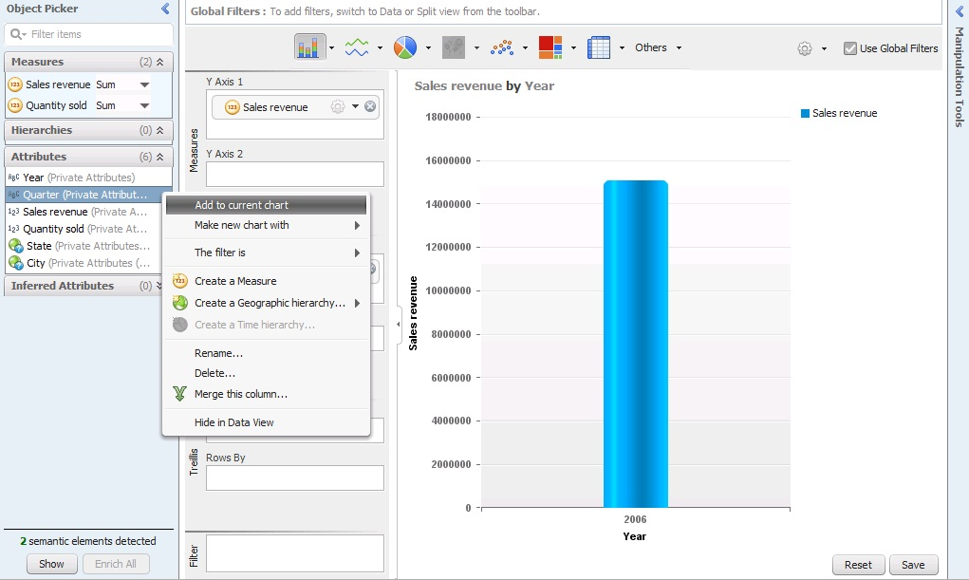
We now have a basic Bar Chart showing Year on X-Axis and Measure – Sales Revenue on Y-Axis. As during Acquisition we have applied a filter called – This Year – and the database had 2006 has the latest year we are only showing data for Year 2006. To get a better perspective for this year let’s bring in quarter to see performance at Quarterly level.
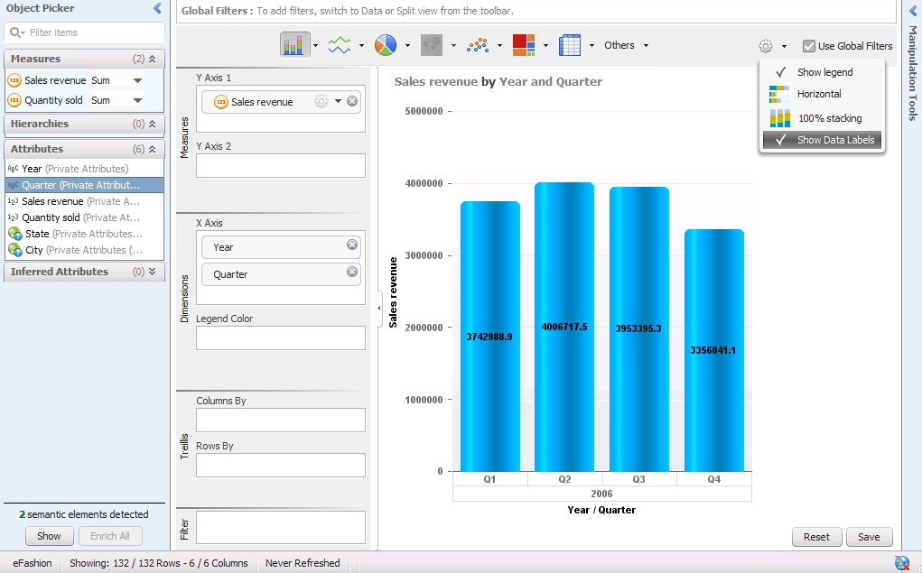
Once we have Quarterly Sales Revenue, we can select the Settings icon on the Right Top above the chart and between Chart Types and Use Global Filters check box and click on its drop down menu. This gives us options to change the chart orientation, type from the family and show Data Labels and Legend which is set by default.
We observe that on the left hand side of the chart we have a collapsible panel called – Chart Feeder – which shows the Y-Axis, X-Axis, Trellis and Filter we can apply on the chart. And the Save button can be used to save the chart as the thumbnail at the bottom of the chart and we can reset the chart to start working on a new chart visualization.
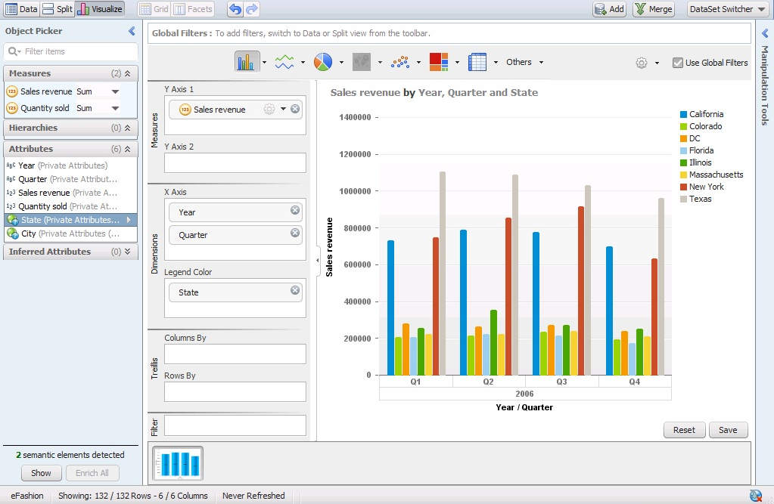
Above we saved the first Visualization with the blue bar chart with Quarterly Sales Revenue, then added State to Legend Colors under Dimensions Section. Basically this allows us to show stacked data, such as in this case we want to see All States and their Sales Revenues by Quarter. We can further Save this as a new Visualization and or change the chart type to a Stacked Bar if wanted. Before that lets look at the chart types available. Below we are showing different Bar Charts available:
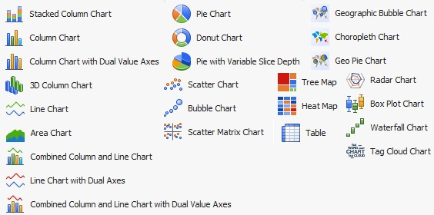
Let select 3D Column Chart and change the Visualization for the same data and save it.
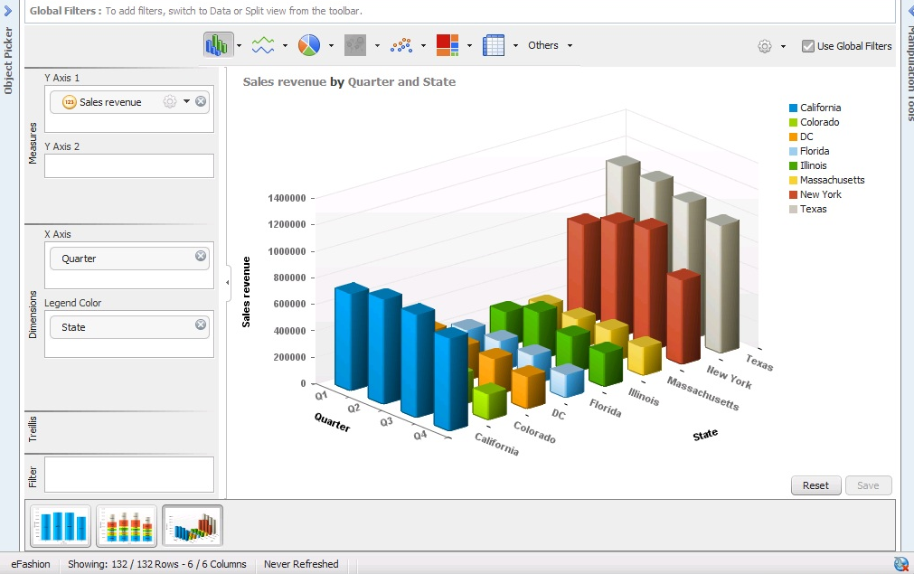

Now if we switch to Share Mode we can see also the saved visualizations based on this data set
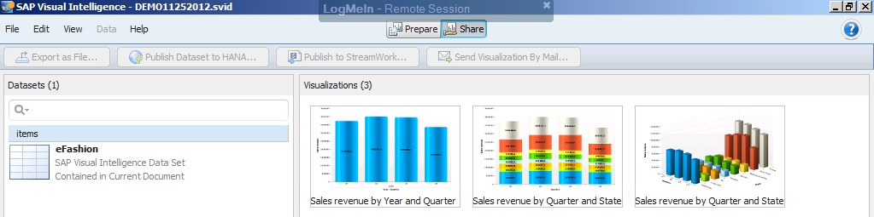
We can select the data set and export it as CSV File:
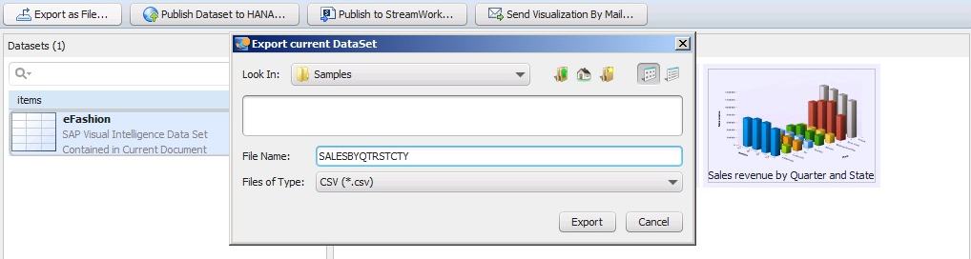
We can copy the visualization by right click and copy and paste it in office documents.
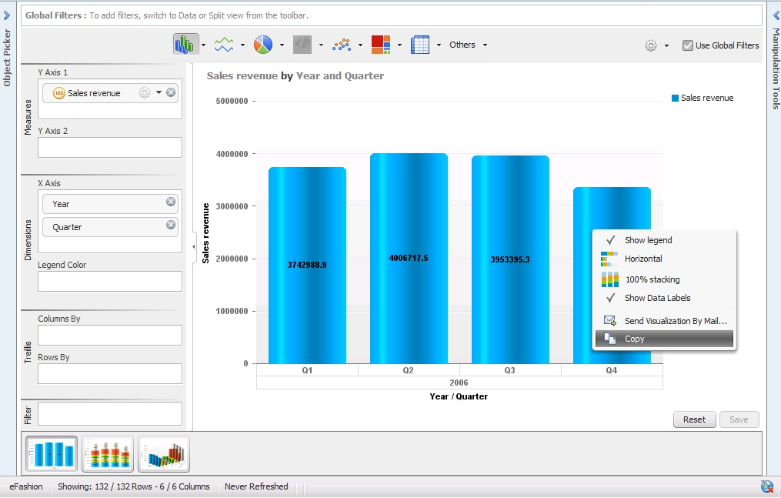
We can also send visualizations as email attachments
Creating Hierarchy for Geography based Objects:
Below we selected the State Attribute and from its contextual menu clicked on Create a Geographic Hierarchy – By Name
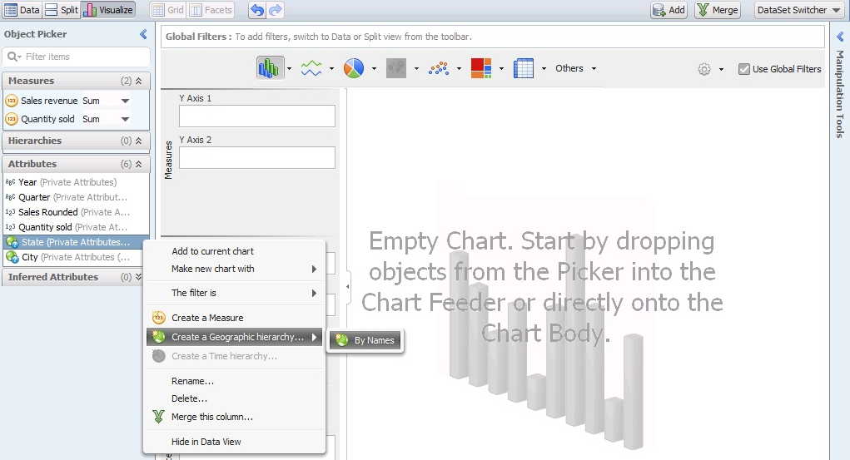
This opens a dialog box to select level of granularity in the Geographical Map
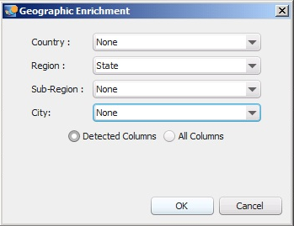
Here we are selecting Sate as Region just below County level.
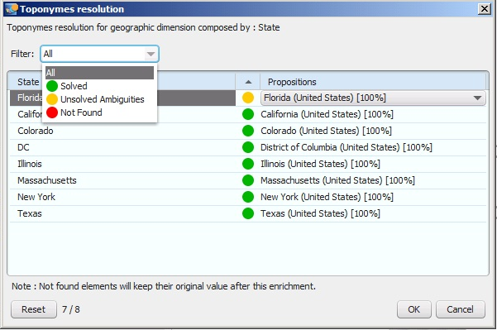
SAP Visual Intelligence will use its internal geography database to map the dataset column values and if matches will show them in green, if not found will show in red, and if the location is ambiguous will show in Yellow, we can then select the appropriate value and set the geographic regions for the maps.
Similarly let’s setup the City in Geographic Hierarchy. Select City and from its contextual menu select – Create a Geographic hierarchy - By Names
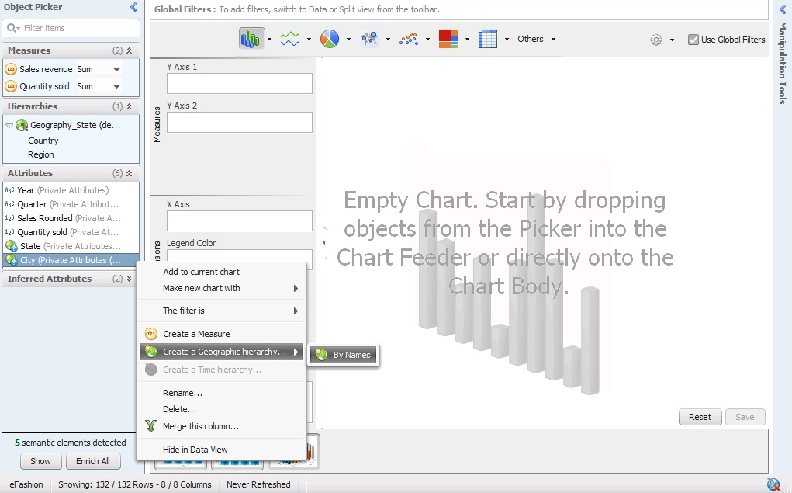
Change the City level from Sub-Region to City
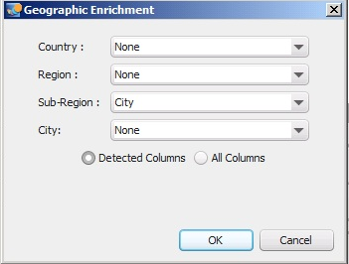
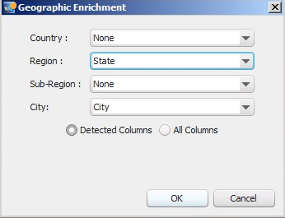
Select all appropriate city mappings if necessary and click ok.
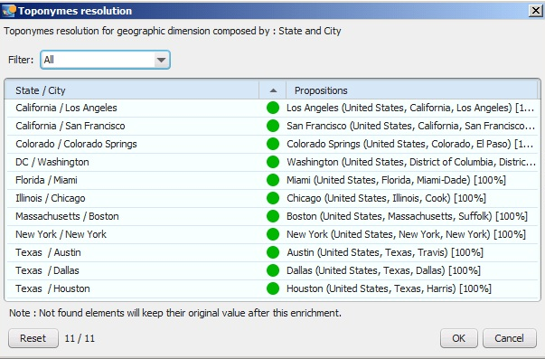

We have a Geographical Bubble Chart showing Cities with Sales Review from States on Map by location.
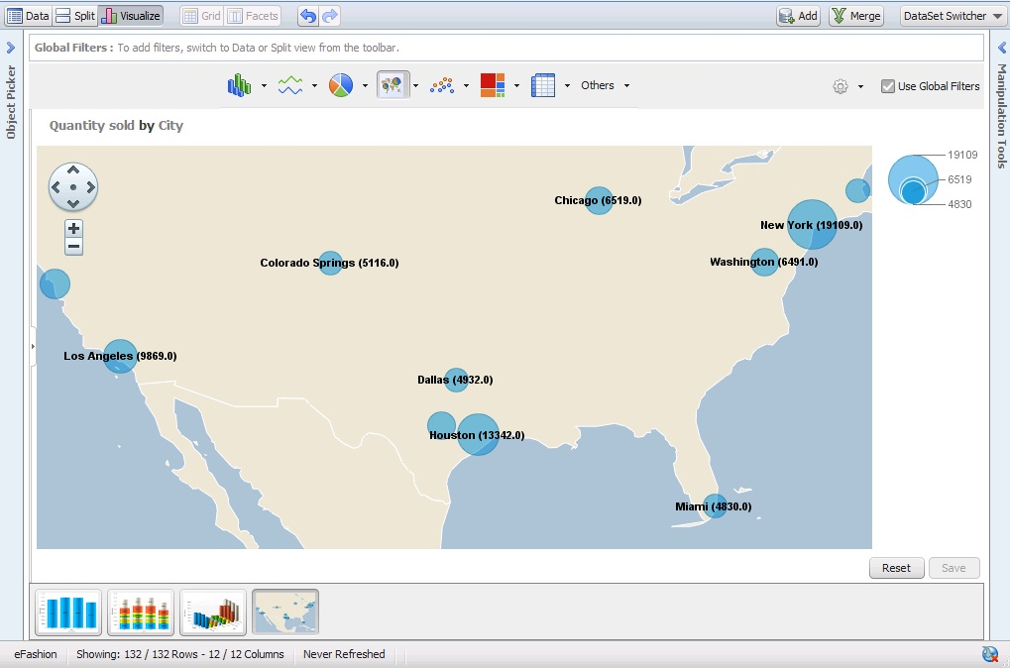

We now see Hierarchies section of Object Picker Pane and observe the two Hierarchies created based on State as Region and City as City.
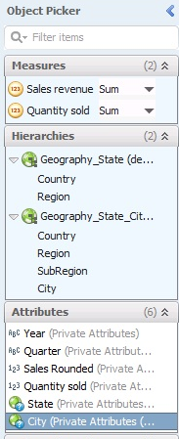
Next lets add or move Quarter to Trellis section of Chart Feeder and we have Sales Revenue by State for all Quarters displayed beside each other.
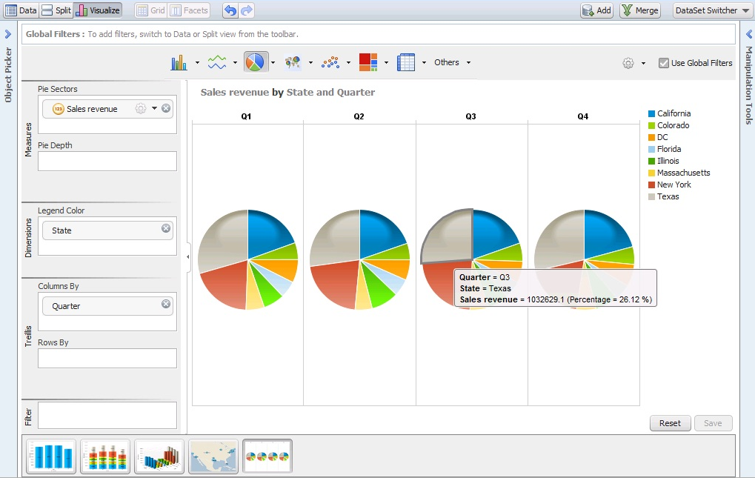
We can also add more datasets and merge data and use Manipulation Tools for cleanse the displayed data and add further calculated measures and formulas built for SAP Visual Intelligence. The Preferences settings in File Menu provide options to change the display views for the tool and change palette and theme colors for charts and have additional settings for Freehand SQL, Auto-Update, Proxy server.

Using above process we created some basic charts based on a single dataset based on SAP BusinessObjects universe and save them in SAP Visual Intelligence Documents folder which is the default folder created during installation and also share this information by email, embedded graphic and exporting the dataset.

